
Course Project Report On
Real-Time Hand-Seal Recognition and Jutsu Sequence Matching Using Classical Pattern Recognition
Submitted in partial fulfillment of the requirements for the award of the degree of
Bachelor of Technology
in
Artificial Intelligence and Data Science
By
Sithaara Jubab Roshan
(U2408077)
Under the guidance of
Ms. Shyama R
Department of Artificial Intelligence and Data Science
Rajagiri School of Engineering & Technology (Autonomous)
(Parent University: APJ Abdul Kalam Technological University)
Rajagiri Valley, Kakkanad, Kochi, 682039
September 2026

CERTIFICATE
This is to certify that the course project report entitled “Real-Time Hand-Seal Recognition and Jutsu Sequence Matching Using Classical Pattern Recognition” is a bonafide record of the work done by Sithaara Jubab Roshan (U2408077), submitted to the Rajagiri School of Engineering & Technology (RSET) (Autonomous) in partial fulfillment of the requirements for the award of the degree of Bachelor of Technology (B. Tech.) in Artificial Intelligence and Data Science during the academic year 2026-2027.
Shyama R  Course Faculty  Assistant Professor  Dept of AI&DS  RSET |  | Dr. Sherly K K  Head of the Department  Professor & HOD  Dept of AI&DS  RSET

ACKNOWLEDGMENT
I wish to express my sincere gratitude towards Rev. Dr. Jaison Paul Mulerikkal CMI, Principal of RSET, and Dr. Sherly K K, Head of the Department of Artificial Intelligence and Data Science, for providing me with the opportunity to undertake my project, “Real-Time Hand-Seal Recognition and Jutsu Sequence Matching Using Classical Pattern Recognition”.
It is indeed my pleasure and a moment of satisfaction for me to express my sincere gratitude to my project guide Ms. Shyama R for her patience and all the priceless advice and wisdom she has shared with me.
Last but not the least, I would like to express my sincere gratitude towards all other teachers and friends for their continuous support and constructive ideas.
Sithaara Jubab Roshan
U2408077

Abstract
This project develops a real-time recognition system for two-handed “hand seals” and a sequence engine that matches ordered seals to named actions, using classical pattern recognition methods. Hand landmarks are extracted from webcam video with MediaPipe, and each sample is a 126-dimensional vector formed from 21 three-dimensional landmarks per hand, made wrist-relative and scale-normalised so that it is insensitive to position and distance. Data were collected under nine capture conditions, and a frame is stored only when both hands are detected; zero-padded single-hand frames, a label-derived feature and a train/serve feature mismatch were identified and removed. The cleaned dataset contains 1593 samples from 79 capture sessions in 8 classes (seven seals and a neutral class). K-Nearest Neighbours, Logistic Regression and Gaussian Naive Bayes, which belong to the course syllabus, and an extra multilayer-network baseline were compared with repeated 5-fold cross-validation grouped by capture session, which prevents near-identical consecutive frames from leaking between training and test sets. KNN reached a macro-F1 of 0.828 ± 0.079 and Logistic Regression and the network were statistically indistinguishable from it, whereas Naive Bayes was clearly lower (0.673). Errors concentrate on seals with interlaced fingers, where hand occlusion limits both detection and recognition. A temporal stabiliser, control seals (start, undo, cast) and exact-match lookup convert per-frame predictions into jutsu, shown with procedural animations and a hover-activated reference list. Compared with work that reports very high accuracy on randomly split frames, the project emphasises leakage-free evaluation, variability estimates and an honest account of occlusion limits.

Contents
Acknowledgment i
Abstract ii
List of Abbreviations v
List of Figures vi
List of Tables vii
1 Introduction 1
1.1 Background 1
1.2 Problem Definition 1
1.3 Scope and Motivation 1
1.4 Objectives 2
1.5 Challenges 3
1.6 Societal / Industrial Relevance 3
1.7 Organization of the Report 3
2 Literature Survey 4
2.1 Vision-Based Hand Gesture Recognition 4
2.2 Landmark-Based Hand Tracking 4
2.3 Classical Classifiers 4
2.4 Evaluation Methodology and Data Leakage 5
2.5 Summary and Gaps Identified 5
3 System Design and Methodology 6
3.1 System Overview 6
3.2 Hand Detection and Landmark Extraction 6
3.3 Feature Engineering 6
3.4 Data Collection Protocol 7
3.5 Data Integrity: Lessons Learned 7
3.5.1 Zero-padded single-hand frames 7
3.5.2 Label leakage 8
3.5.3 Train/serve mismatch 8
4 Pattern Recognition Methods and Live Application 9
4.1 Classifiers 9
4.1.1 K-Nearest Neighbours (syllabus: Module 2) 9
4.1.2 Logistic Regression (syllabus: Modules 2–3) 9
4.1.3 Gaussian Naive Bayes (syllabus: Module 3) 9
4.1.4 Multilayer perceptron (extra, beyond the syllabus) 9
4.2 Experimental Setup 10
4.3 Seal Stabilisation and Sequence Recognition 10
4.4 Interactive Interface and Animations 11
5 Results and Discussions 13
5.1 Dataset Statistics 13
5.2 Model Comparison 14
5.3 Per-Seal Analysis 14
5.4 Discussion 16
5.4.1 KNN, Logistic Regression and the MLP are statistically indistinguishable 16
5.4.2 Why Gaussian Naive Bayes is weaker 16
5.4.3 Choice of the live model 16
5.4.4 Seal vocabulary and occlusion 16
5.5 Live Application Behaviour 17
5.6 Threats to Validity and Limitations 17
6 Conclusions & Future Scope 18
References 19
Appendix A: Source Files and Reproduction 20

List of Abbreviations
CV – Cross-Validation
GNB – Gaussian Naive Bayes
HCI – Human–Computer Interaction
KNN – K-Nearest Neighbours
LR – Logistic Regression
MLP – Multilayer Perceptron
PCA – Principal Component Analysis
RGB – Red, Green, Blue
UI – User Interface

List of Figures
Figure 1.1 Overview of the proposed system, from webcam frame to jutsu display. 1
Figure 3.1 The 21 hand landmarks. Landmarks 0 (wrist) and 9 (middle-finger base) define the normalisation. 6
Figure 3.2 Share of raw frames per seal with both hands detected (kept) and with one hand only (removed). 8
Figure 4.1 State machine for sequence recording and jutsu matching. 11
Figure 4.2 Screenshot of the live application (camera view, seal panel, sequence bar). 12
Figure 5.1 Accuracy and macro-F1 of the four classifiers (error bars: one standard deviation over 15 folds). 14
Figure 5.2 Recall per seal for each classifier. 15
Figure 5.3 Confusion matrices (pooled out-of-fold counts) for KNN (left) and Gaussian Naive Bayes (right). 15

List of Tables
Table 1.1 Mapping of project components to the Pattern Recognition syllabus. 2
Table 2.1 Summary of surveyed work. 5
Table 3.1 The nine capture conditions used for every seal. 7
Table 4.1 Classifier configurations (scikit-learn [11]). 10
Table 4.2 Control seals and timing parameters of the live system (default configuration). 11
Table 4.3 Jutsu table in the default configuration. Sequences are inspired by, but not identical to, canonical sequences and use only seals the model was trained on. 11
Table 5.1 Cleaned dataset used for all experiments. 13
Table 5.2 Raw frames per seal and the share with both hands detected. 13
Table 5.3 Classifier comparison (mean ± standard deviation over 15 session-grouped folds). 14
Table 5.4 Per-seal recall from pooled out-of-fold predictions. 14
Table 5.5 Most frequent confusion for each true class (five largest shares). 15
Table A.1 Project source files. 20

Chapter 1
Introduction
This chapter introduces the project: the background of vision-based gesture interfaces, the precise problem addressed, the scope and motivation, the objectives, the main challenges, the relevance of the work, and the organisation of the rest of the report.

1.1 Background
Hand gestures are a natural channel for human–computer interaction, and vision-based recognition, which needs only a camera and no wearable sensor, has been an active research area for decades [1]. Classical gesture-recognition systems follow three phases (detection, tracking and recognition) [1]. Modern landmark-based trackers have simplified the first two phases. MediaPipe Hands, for example, predicts a 21-point hand skeleton from a single RGB camera in real time using a palm detector followed by a hand-landmark model, and it is designed to remain robust under partial visibility and self-occlusion [2], [3].
Once a hand is reduced to a small set of landmark coordinates, recognising a static pose becomes a conventional supervised pattern recognition problem. This makes it a good setting for studying the methods taught in a Pattern Recognition course: feature design, distance-based classification, probabilistic classification, and, above all, careful evaluation. This project uses that setting with a deliberately playful target, the two-handed “hand seals” of the Naruto franchise, to build a complete pipeline from webcam frames to a live interactive application.

1.2 Problem Definition
The aim is to recognise a small vocabulary of static two-handed seals in real time from a webcam, to compare classical pattern recognition classifiers on the task under a leakage-free evaluation, and to use the recognised seals to drive a sequence-matching application in which ordered seals trigger named “jutsu”.
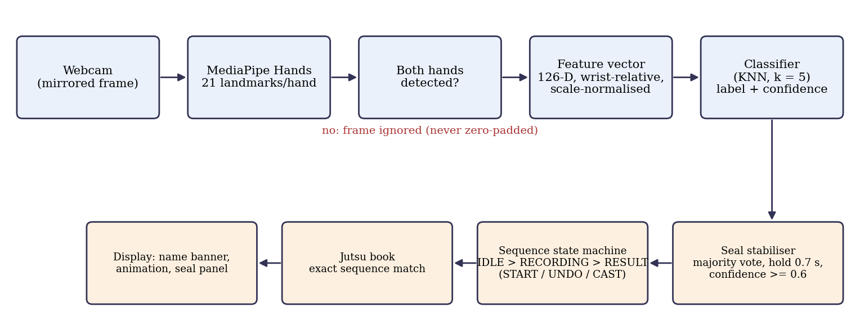
Figure 1.1: Overview of the proposed system, from webcam frame to jutsu display.

1.3 Scope and Motivation
The scope is limited to static seals performed with both hands in front of a single laptop webcam. Each frame is classified independently into one of 8 classes (seven seals and one neutral “no seal” class), and sequences are handled by a rule-based state machine on top of the classifier output rather than by a learned temporal model. Four classifiers are compared: K-Nearest Neighbours, Logistic Regression and Gaussian Naive Bayes, which belong to the course syllabus, and a small multilayer neural network included as an extra, out-of-syllabus baseline. The scope deliberately excludes dynamic gestures, multiple users and depth sensors.
The motivation is twofold. Academically, a small landmark-based dataset exposes exactly the issues that matter in practice: correlated features, few independent capture sessions, and the risk that near-identical consecutive frames leak between training and test sets. Practically, a working interactive demonstration makes the abstract classifier comparison tangible, and it forces design decisions (confidence cut-offs, hold times, a restricted seal vocabulary) that mirror real deployment trade-offs.
Table 1.1: Mapping of project components to the Pattern Recognition syllabus.
Syllabus module | Topic | Where it appears in this project
Module 1 | Decision functions; linear vs non-linear; multi-class | Logistic Regression (linear boundaries) vs KNN and MLP (non-linear); one-vs-rest style multi-class decisions over 8 classes
Module 2 | Distance measures; minimum-distance classification; KNN; logistic regression; cut-offs; Type I/II errors | KNN with Euclidean distance on standardised features (k = 5); confidence cut-off of 0.6 in the live system; per-seal precision/recall as error analysis
Module 3 | Bayes theorem, posterior, Naive Bayes; overfitting; regularisation | Gaussian Naive Bayes; L2-regularised Logistic Regression (library default); session-grouped cross-validation to expose overfitting
Module 5 | Neural networks (perceptron); PCA | MLP used only as an extra baseline beyond the syllabus. PCA was not used in the final pipeline and is listed as future work

1.4 Objectives
- To extract a position- and scale-invariant 126-dimensional feature vector for two-handed seals from MediaPipe hand landmarks.
- To collect a labelled dataset under nine varied capture conditions and to enforce a strict rule that only frames with both hands detected are stored.
- To compare KNN, Logistic Regression and Gaussian Naive Bayes, with a neural network as an extra baseline, using repeated session-grouped cross-validation.
- To analyse per-seal reliability using out-of-fold recall and confusion matrices, and to relate failures to hand occlusion.
- To build a live application with temporal stabilisation, control seals (START, UNDO, CAST), and exact-match sequence-to-jutsu lookup.
- To document honestly the limitations and the methodological lessons (label leakage, train/serve mismatch, data leakage between frames).

1.5 Challenges
Two-handed seals involve interlaced fingers, so one hand often occludes the other and the landmark detector may lose a hand entirely; in the raw data only 1725 of 2550 captured frames had both hands detected. Consecutive webcam frames are almost identical, which makes naive random train/test splits optimistic. Finally, the number of independent capture sessions per seal is small (8 to 15), so any performance estimate has a large variance.

1.6 Societal / Industrial Relevance
The same pipeline (landmark extraction, normalisation, a lightweight classifier and a temporal state machine) applies directly to touch-free interfaces, assistive communication using static sign alphabets, gesture control in kiosks or sterile environments, and educational or entertainment applications. Because the classifiers are small and run on a CPU, the approach is also relevant where deep models are impractical.

1.7 Organization of the Report
Chapter 2 surveys related work and identifies gaps. Chapter 3 describes the system design, feature engineering and data collection. Chapter 4 describes the classifiers, the experimental setup, and the sequence engine and interface. Chapter 5 presents and discusses results. Chapter 6 concludes and outlines future work. The Appendix lists the source files.

Chapter 2
Literature Survey
This chapter reviews vision-based hand gesture recognition, landmark-based hand tracking, the classical classifiers used in this project, and evaluation methodology, and then summarises the gaps this project addresses.

2.1 Vision-Based Hand Gesture Recognition
Rautaray and Agrawal survey vision-based gesture recognition for human–computer interaction, organising the field around detection, tracking and recognition, and discussing gesture representations, applications and open problems [1]. A recurring conclusion in that literature is that robust recognition under varied viewpoints, lighting and backgrounds remains difficult, which motivates representations that are invariant to such factors.

2.2 Landmark-Based Hand Tracking
MediaPipe Hands uses two models: a palm detector and a hand-landmark model that regresses 21 landmarks, each with x, y and a relative depth value, from a single RGB image [2]. It is built on the MediaPipe framework for cross-platform perception pipelines [3], runs in real time on commodity hardware and is reported to be robust to partially visible hands and self-occlusion [2]. Because the landmarks are low-dimensional and already encode hand geometry, they can be fed to light-weight classifiers without learning features from pixels.
Several studies use MediaPipe landmarks for sign-language recognition. Kumar et al. classify ASL alphabets from normalised landmarks with a convolutional network and report 99.95% accuracy on a held-out 20% split of a large image dataset [4]; their feature preparation (subtracting a reference point and dividing by a scale factor) is similar in spirit to the normalisation used here. Sundar and Bagyammal combine MediaPipe with an LSTM for ASL alphabets, reporting about 99% accuracy as summarised in [4], [5]. In both cases the text we reviewed describes a random dataset split and does not state that splits are grouped by signer or capture session, so the reported accuracies may be optimistic for unseen conditions (see Section 2.4).

2.3 Classical Classifiers
The k-nearest-neighbour rule assigns a sample the majority label among its k closest training samples under a chosen distance; Cover and Hart showed that its asymptotic error is bounded by twice the Bayes error [6]. Distance-based classification and distance measures are standard material in pattern classification texts [7]. Logistic regression models class posteriors with a linear function followed by a logistic (or softmax) link and is trained by maximum likelihood, usually with L2 regularisation [12]. Naive Bayes applies Bayes’ theorem under a conditional-independence assumption; Domingos and Pazzani showed that the classifier can nevertheless be optimal under zero-one loss even when that assumption is violated by a wide margin, so poor performance cannot be attributed to the independence assumption alone [8].

2.4 Evaluation Methodology and Data Leakage
Cross-validation is the standard way to estimate generalisation error and to select models [9]. It assumes that samples are independent, which fails for video: consecutive frames from one capture are near-duplicates, so a random split puts almost the same sample in both training and test sets. This is an instance of leakage, defined by Kaufman et al. as the introduction of information about the target that should not legitimately be available to the model [10]. Grouping cross-validation folds by capture session is a direct remedy and is available in scikit-learn [11].

2.5 Summary and Gaps Identified
Table 2.1: Summary of surveyed work.
Reference | Advantages | Disadvantages / limitations
Rautaray & Agrawal [1] | Broad taxonomy of detection, tracking and recognition; identifies open problems | Survey only; no implementation or benchmark for modern landmark trackers
Zhang et al. [2] | Real-time on-device 21-landmark hand tracking from RGB; robust to partial visibility | Landmarks can still be lost or wrong under heavy two-hand occlusion; depth is relative only
Kumar et al. [4] | Normalised landmarks + CNN; very high reported accuracy | Random dataset split described; no grouping by signer/session; single-hand alphabets
Sundar & Bagyammal [5] | MediaPipe + LSTM for ASL alphabets (as summarised in [4]) | Deep model; primary evaluation protocol not reviewed here
Domingos & Pazzani [8] | Explains why Naive Bayes can work despite dependent features | General theory; does not address landmark data
Kaufman et al. [10] | Formal treatment of leakage and how to detect and avoid it | General data-mining setting; not specific to video frames

The following gaps motivate this work:
- Two-handed seals with interlaced fingers are rarely studied; most landmark-based work targets single-hand alphabets, so occlusion-induced detector failures are under-reported.
- Many reported accuracies rely on random splits of video frames and may overstate performance; session-grouped evaluation with variability estimates is less common.
- Deep models are often used by default, with little comparison against the simple distance-based and probabilistic classifiers on the same landmark features.
- Interactive systems that go beyond single-gesture recognition to sequences with explicit control gestures (start, undo, confirm) are seldom documented together with their classifier evaluation.
In summary, the literature motivates landmark features and shows that classical classifiers are credible, but leaves open how reliably they handle occluded two-handed poses under leakage-free evaluation, which is the focus of the following chapters.

Chapter 3
System Design and Methodology
This chapter describes the system pipeline, the extraction and normalisation of landmark features, the data-collection protocol, and the measures taken to keep the dataset free of artefacts.

3.1 System Overview
The pipeline in Figure 1.1 has five stages. A mirrored webcam frame is passed to MediaPipe Hands; if both hands are detected, a 126-dimensional feature vector is computed; a classifier outputs a seal label and a confidence; a temporal stabiliser converts the noisy per-frame predictions into discrete seal events; and a state machine consumes those events to record sequences and match them against a table of jutsu. All stages that touch the features (collection, training and live use) share one module, so training-time and run-time features cannot diverge.

3.2 Hand Detection and Landmark Extraction
Frames are captured at up to 1280 × 720 pixels, mirrored horizontally so that the on-screen left hand is the user’s left, and processed by MediaPipe Hands configured for up to two hands, model complexity 1, and detection and tracking confidence thresholds of 0.5 [2]. Each detected hand yields 21 landmarks (Figure 3.1). The two hands are ordered left to right on screen by the horizontal position of the wrist (landmark 0), which defines the “L” and “R” halves of the feature vector independently of the detector’s own handedness label.
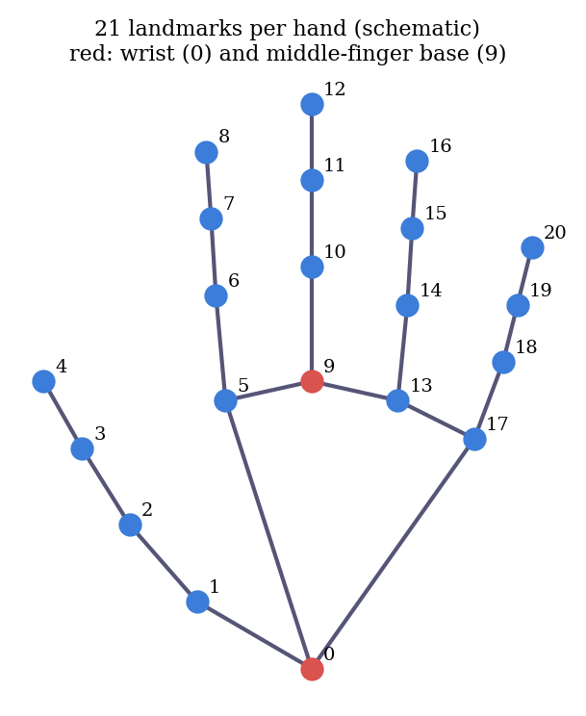
Figure 3.1: The 21 hand landmarks. Landmarks 0 (wrist) and 9 (middle-finger base) define the normalisation.

3.3 Feature Engineering
Raw landmark coordinates depend on where the hand is in the frame and how far it is from the camera. For each hand, every landmark p_{i} is translated so that the wrist is the origin and then divided by the wrist-to-middle-finger-base distance:
q_{i} = ( p_{i} − p₀ ) / ‖ p₉ − p₀ ‖₂, i = 0, …, 20 (3.1)
Each p_{i} has three components (x, y, z), so a hand contributes 63 numbers. The feature vector concatenates the screen-left and screen-right hands:
x = [ q^{L}₀, …, q^{L}₂₀, q^{R}₀, …, q^{R}₂₀ ] ∈ R¹²⁶ (3.2)
Before classification every feature is standardised to zero mean and unit variance using statistics from the training folds only. A sample is produced only when both hands are detected; a missing hand is never replaced by zeros.

3.4 Data Collection Protocol
For each seal, data were collected in nine capture conditions (Table 3.1) that vary distance, tilt and position in the frame. In the final collector, each condition begins with a five-second preparation countdown and then stores 25 frames at 0.1-second intervals, counting only frames in which both hands are detected. The 25 frames of a condition are written together and share a session identifier, so an interrupted condition leaves no partial data and every row can be traced to its capture session. The data were collected by the author [CONFIRM: single subject, single webcam, single environment].
Table 3.1: The nine capture conditions used for every seal.
No. | Condition
1 | Straight-on, medium distance, centred
2 | Straight-on, close to the camera, centred
3 | Straight-on, far from the camera, centred
4 | Tilted slightly left, medium distance, centred
5 | Tilted slightly right, medium distance, centred
6 | Straight-on, medium distance, shifted left in the frame
7 | Straight-on, medium distance, shifted right in the frame
8 | Tilted left, close to the camera, centred
9 | Tilted right, far from the camera, centred

3.5 Data Integrity: Lessons Learned
Three methodological problems were found and corrected during development; they are reported because they illustrate how easily a landmark pipeline can produce misleading results.

3.5.1 Zero-padded single-hand frames
An early collector accepted frames in which only one hand was detected and filled the missing hand with 63 zeros. Such rows do not describe any real pose, and a classifier can learn to use the zero block itself as a cue, which then behaves unpredictably whenever the detector happens to drop a hand at run time. Figure 3.2 shows how common this was: for the seals with the most interlaced fingers, most raw frames had only one hand (for example, only 17.8% of Dragon and 40.9% of Tiger frames had both hands). All single-hand rows were removed, and the collector now enforces the strict both-hands rule.
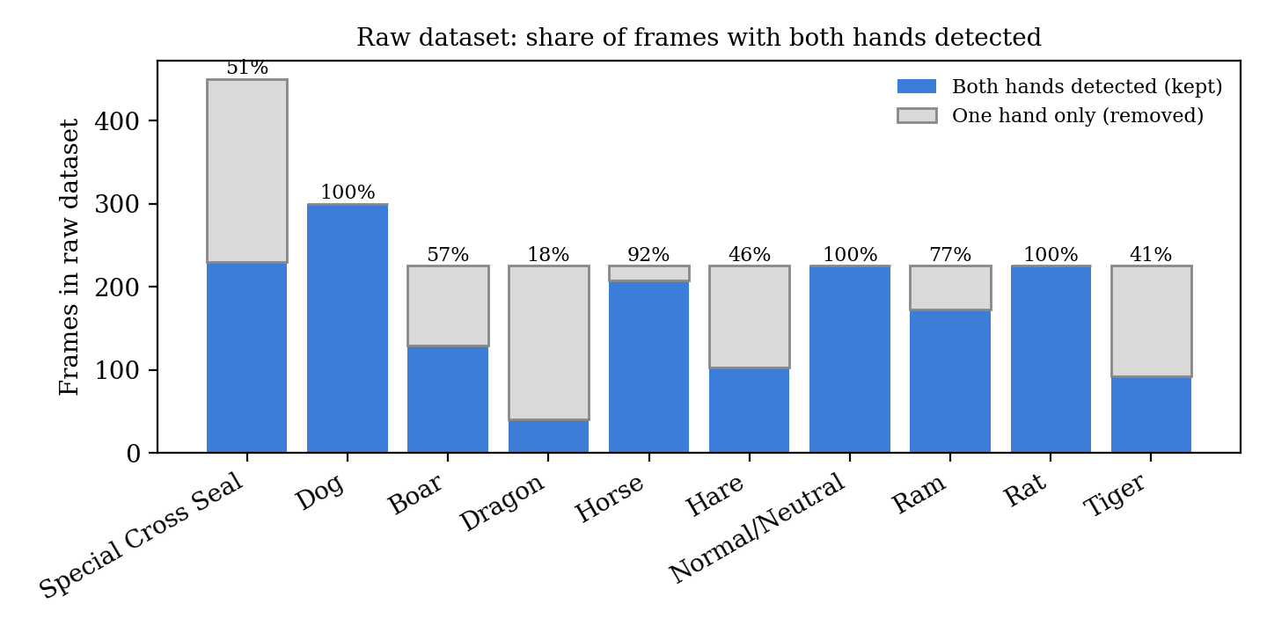
Figure 3.2: Share of raw frames per seal with both hands detected (kept) and with one hand only (removed).
After this cleaning, Dragon (40 usable rows) and Tiger (92 rows) fell below the minimum of 100 rows and were dropped from the vocabulary. [CONFIRM: if Dragon and Tiger are re-collected, update Chapter 5]

3.5.2 Label leakage
A helper script had added a “wrist distance” column whose value was derived from the seal label (a larger value for seals where the hands are far apart, plus noise). Because a feature computed from the label carries the answer, it would have produced inflated accuracy. The column was never used for training and was removed from the dataset; the feature vector contains only the 126 landmark-derived values.

3.5.3 Train/serve mismatch
The data-collection script and the live script originally computed features separately and placed a single visible hand into different halves of the vector. Moving all feature code into one shared module removes this class of error: the model sees at run time exactly the representation it was trained on.
Chapter 3 therefore fixes a normalised 126-dimensional representation, a collection protocol that records provenance (session) for every row, and a dataset free of zero-padding and label leakage.

Chapter 4
Pattern Recognition Methods and Live Application
This chapter describes the classifiers and their settings, the evaluation protocol, the temporal stabiliser and sequence state machine, and the interactive interface.

4.1 Classifiers
All four classifiers sit behind the same standardisation step in a single pipeline, so the scaler is fitted on training folds only. Hyperparameters are library defaults except where stated (Table 4.1); they were not tuned, which is noted as a limitation.

4.1.1 K-Nearest Neighbours (syllabus: Module 2)
A sample is assigned the majority label among its k = 5 nearest training samples under Euclidean distance on the standardised features [6], [7]:
d( z, z′ ) = ( Σ_{j=1}¹²⁶ ( z_{j} − z′_{j} )² )^{1/2} (4.1)
With uniform weights the predicted probability of a class is the fraction of the five neighbours that vote for it, so it can only take the values 0, 0.2, …, 1. A live confidence cut-off of 0.6 therefore means that at least three of the five neighbours must agree.

4.1.2 Logistic Regression (syllabus: Modules 2–3)
The multi-class model assigns class posteriors with a softmax over linear scores, fitted by maximum likelihood with an L2 penalty (regularisation strength at the library default) [12]:
P( y = c | x ) = exp( w_{c}·x + b_{c} ) / Σ_{k} exp( w_{k}·x + b_{k} ) (4.2)

4.1.3 Gaussian Naive Bayes (syllabus: Module 3)
By Bayes’ theorem the posterior is proportional to the class prior times the likelihood; the naive assumption factorises the likelihood over features, each modelled as a class-conditional Gaussian [8], [12]:
P( c | x ) ∝ P( c ) Π_{j} N( x_{j} ; μ_{cj}, σ²_{cj} ) (4.3)

4.1.4 Multilayer perceptron (extra, beyond the syllabus)
A fully connected network with two hidden layers (128 and 64 ReLU units), an L2 penalty and the Adam optimiser, trained on the same standardised features. The syllabus covers only the single-layer perceptron [13]; this model is therefore reported as an extra baseline and is not the model used for live recognition.
Table 4.1: Classifier configurations (scikit-learn [11]).
Model | Configuration
KNN | k = 5, Euclidean distance, uniform weights
Logistic Regression | Multinomial, L2 penalty, default strength, up to 2000 iterations
Gaussian Naive Bayes | Library defaults (per-feature class-conditional Gaussians)
MLP (extra) | Hidden layers (128, 64), ReLU, Adam, L2 penalty 10⁻³, up to 500 iterations, random seed 42
Preprocessing (all) | Standardisation (zero mean, unit variance) fitted on training folds only

4.2 Experimental Setup
Models are evaluated with 5-fold cross-validation grouped by session identifier, so that all frames of a capture condition fall entirely in either the training or the test side of a fold. The procedure is repeated three times with a different random assignment of sessions to folds, giving 15 folds per model. Reported values are the mean and standard deviation over these 15 folds. Because the three repeats reuse the same data, the folds are not independent and the standard deviation is a descriptive measure of variability rather than a basis for a formal significance test. Metrics are overall accuracy and macro-averaged precision, recall and F1, where the macro average gives each class equal weight regardless of its size:
F1_{c} = 2 P_{c} R_{c} / ( P_{c} + R_{c} ), macro-F1 = (1/C) Σ_{c=1}^{C} F1_{c} (4.4)
Confusion matrices and per-seal recall are computed from the pooled out-of-fold predictions of the first repeat, in which every sample is predicted exactly once by a model that never saw its session. Using the per-class precision and recall also gives the Type I (false positive) and Type II (false negative) error rates of each seal.

4.3 Seal Stabilisation and Sequence Recognition
Per-frame predictions flicker, and a seal must be a deliberate event, not a single frame. A stabiliser keeps a window of the last 9 predictions (a prediction below the confidence cut-off of 0.6 counts as “no prediction”). A seal is accepted when it is the majority label (at least 6 of the 9 frames) continuously for 0.7 seconds, and it is emitted once; the same seal can be registered again only after the majority label has changed, for example by relaxing the hands to the neutral class.
Accepted seals drive the state machine in Figure 4.1. Three control seals are reserved (Table 4.2) and cannot appear inside jutsu sequences: START begins recording from the IDLE state, UNDO removes the last recorded seal, and CAST ends the sequence, looks it up by exact match in the jutsu table, and enters the RESULT state, in which the jutsu name and an animation are shown for 6 seconds (or a “no match” message). A recording that receives no seal for 40 seconds is discarded, and sequences are limited to 8 seals.
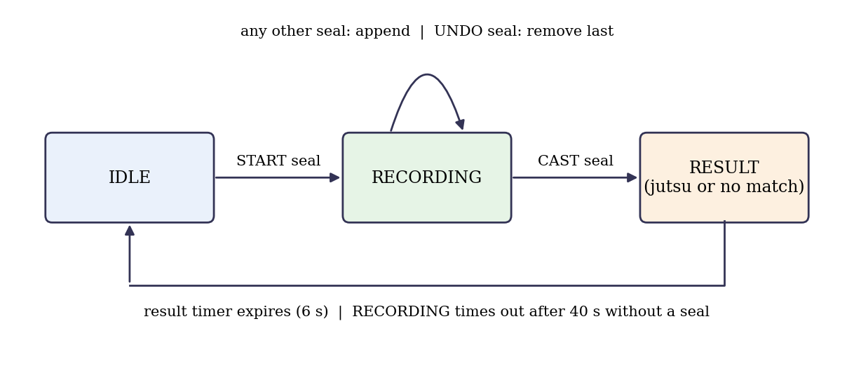
Figure 4.1: State machine for sequence recording and jutsu matching.
Table 4.2: Control seals and timing parameters of the live system (default configuration).
Item | Value
START / UNDO / CAST seals | Dog / Rat / Special Cross Seal [CONFIRM final choice after data are finalised]
Hold time; window; agreement | 0.7 s; last 9 predictions; at least 6 of 9 agree
Confidence cut-off | 0.6 (for KNN: at least 3 of 5 neighbours)
Result display; recording timeout; maximum length | 6 s; 40 s; 8 seals
Select-jutsu button dwell time | 7 s with one hand visible

Table 4.3: Jutsu table in the default configuration. Sequences are inspired by, but not identical to, canonical sequences and use only seals the model was trained on.
Jutsu | Seal sequence | Animation theme
Fireball Jutsu | Ram, Horse, Boar | Fire particles
Shadow Clone Jutsu | Ram, Boar | Smoke burst
Rasengan | Horse, Boar | Spiral
Reaper Death Seal | Boar, Ram, Hare, Horse | Dark overlay

[CONFIRM: replace Table 4.3 with your final sequences. Note that Hare is the least reliable seal (Chapter 5), so a sequence containing it is harder to perform.]

4.4 Interactive Interface and Animations
The application window is divided into the camera view (960 × 540 pixels by default, adjustable), a right-hand panel showing a reference picture of every seal, and a bottom bar showing the current state and the recorded sequence. The panel highlights the currently detected seal with a progress bar for the hold time and tags the three control seals. A “Select Jutsu” button in the camera view is pressed by showing exactly one hand and holding the index fingertip (landmark 8) inside it for 7 seconds; it toggles a reference list of jutsu and their seal sequences. Using one hand as a pointer and two hands for seals prevents the two modes from interfering. Keyboard shortcuts duplicate the button for debugging.
Animations are generated procedurally with OpenCV (particle systems for fire, smoke, a spiral and a darkening effect, blended additively over the camera image). If a clip named after the jutsu is placed in the effects folder it is played instead with additive blending, which is suitable for clips with a black background.
[PLACEHOLDER: insert a real screenshot of jutsu_app.py while a sequence is being recorded]
Figure 4.2: Screenshot of the live application (camera view, seal panel, sequence bar).
Chapter 4 has defined the classifiers, a leakage-aware evaluation protocol, and the sequence engine that turns per-frame predictions into jutsu.

Chapter 5
Results and Discussions
This chapter reports the dataset statistics, compares the classifiers, analyses individual seals, and discusses the findings and their limits. All numbers come from the project’s result files (model_comparison_results.csv, per_seal_recall.csv and the cleaned dataset).

5.1 Dataset Statistics
After removing single-hand frames and the seals with fewer than 100 usable rows, the dataset used for all experiments contains 1593 samples from 79 capture sessions in 8 classes (Table 5.1). The classes are moderately imbalanced (103 to 300 rows), and the number of independent sessions per class is only 8 to 15.
Table 5.1: Cleaned dataset used for all experiments.
Seal / class | Rows | Sessions
Boar | 129 | 8
Dog | 300 | 12
Hare | 103 | 8
Horse | 208 | 9
Normal/Neutral | 225 | 9
Ram | 173 | 9
Rat | 225 | 9
Special Cross Seal | 230 | 15
Total | 1593 | 79

Table 5.2: Raw frames per seal and the share with both hands detected.
Seal / class | Raw rows | Both hands | One hand | Both hands (%)
Boar | 225 | 129 | 96 | 57.3
Dog | 300 | 300 | 0 | 100.0
Dragon | 225 | 40 | 185 | 17.8
Hare | 225 | 103 | 122 | 45.8
Horse | 225 | 208 | 17 | 92.4
Normal/Neutral | 225 | 225 | 0 | 100.0
Ram | 225 | 173 | 52 | 76.9
Rat | 225 | 225 | 0 | 100.0
Special Cross Seal | 450 | 230 | 220 | 51.1
Tiger | 225 | 92 | 133 | 40.9

Rows shaded in Table 5.2 (Dragon and Tiger) were dropped because fewer than 100 usable rows remained. The raw dataset contained 2550 rows, of which 1725 had both hands detected.

5.2 Model Comparison
Table 5.3: Classifier comparison (mean ± standard deviation over 15 session-grouped folds).
Model | Accuracy | Precision | Recall | Macro-F1 | Syllabus
KNN (k = 5) | 0.901 ± 0.034 | 0.858 | 0.839 | 0.828 ± 0.079 | Yes
Logistic Regression | 0.898 ± 0.065 | 0.838 | 0.832 | 0.822 ± 0.126 | Yes
MLP (extra) | 0.885 ± 0.064 | 0.842 | 0.830 | 0.818 ± 0.109 | No
Gaussian Naive Bayes | 0.764 ± 0.104 | 0.730 | 0.712 | 0.673 ± 0.105 | Yes

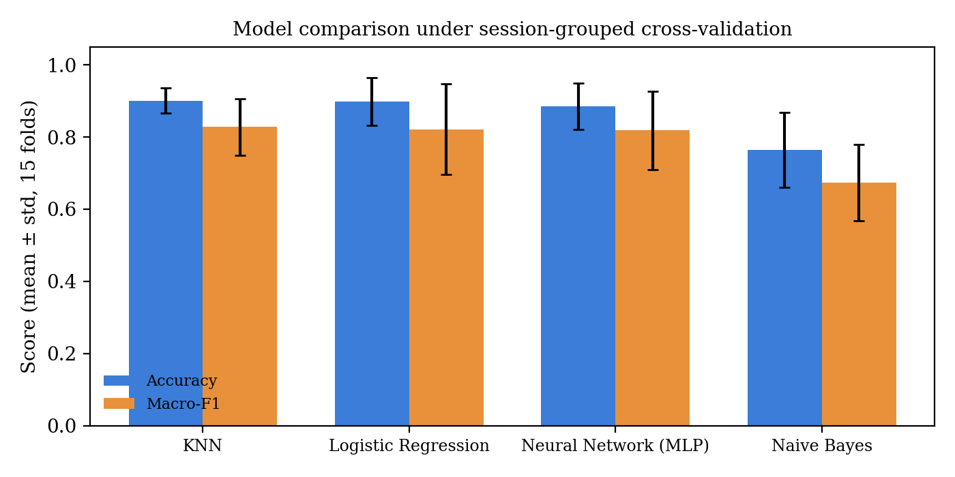
Figure 5.1: Accuracy and macro-F1 of the four classifiers (error bars: one standard deviation over 15 folds).
KNN has the highest mean accuracy (0.901) and macro-F1 (0.828), followed closely by Logistic Regression (0.898 and 0.822) and the MLP (0.885 and 0.818). Gaussian Naive Bayes is clearly lowest (accuracy 0.764, macro-F1 0.673).

5.3 Per-Seal Analysis
Table 5.4: Per-seal recall from pooled out-of-fold predictions.
Seal / class | KNN | Logistic Reg. | Naive Bayes | MLP (extra)
Boar | 0.984 | 0.938 | 0.760 | 0.977
Dog | 0.957 | 0.937 | 0.980 | 0.980
Hare | 0.650 | 0.689 | 0.214 | 0.689
Horse | 0.865 | 0.913 | 0.620 | 0.889
Normal/Neutral | 0.902 | 0.929 | 0.880 | 0.880
Ram | 0.942 | 0.873 | 0.769 | 0.873
Rat | 0.960 | 0.733 | 0.556 | 0.724
Special Cross Seal | 0.874 | 0.835 | 0.865 | 0.874

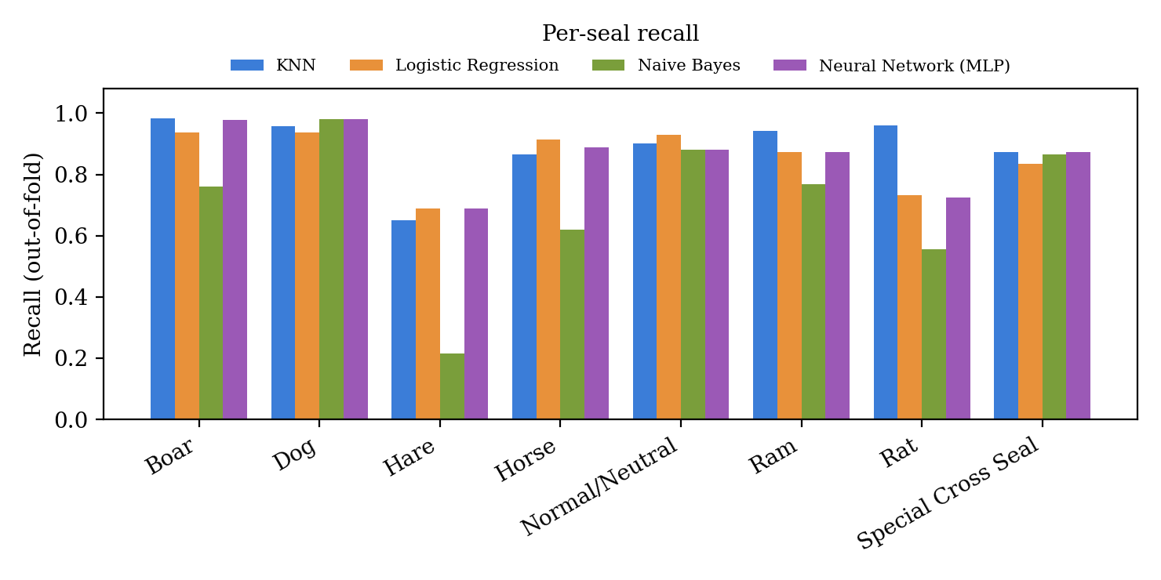
Figure 5.2: Recall per seal for each classifier.
Most seals are recognised well by KNN (recall between 0.865 and 0.984 for every class except Hare). Hare is the weak point for every model: recall is 0.650 for KNN, 0.689 for Logistic Regression and the MLP, and only 0.214 for Naive Bayes. The confusion matrices (Figure 5.3, Table 5.5) show where the errors go.
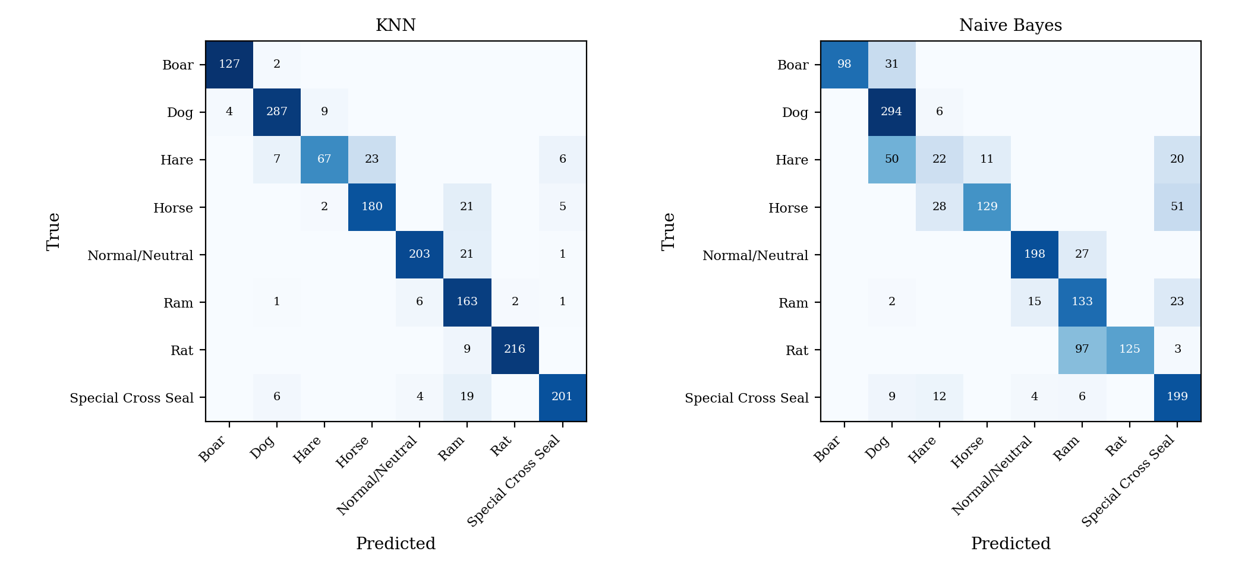
Figure 5.3: Confusion matrices (pooled out-of-fold counts) for KNN (left) and Gaussian Naive Bayes (right).
Table 5.5: Most frequent confusion for each true class (five largest shares).
KNN: true → predicted | Frames | Naive Bayes: true → predicted | Frames
Hare → Horse | 23 of 103 (22.3%) | Hare → Dog | 50 of 103 (48.5%)
Horse → Ram | 21 of 208 (10.1%) | Rat → Ram | 97 of 225 (43.1%)
Normal/Neutral → Ram | 21 of 225 (9.3%) | Horse → Special Cross Seal | 51 of 208 (24.5%)
Special Cross Seal → Ram | 19 of 230 (8.3%) | Boar → Dog | 31 of 129 (24.0%)
Rat → Ram | 9 of 225 (4.0%) | Ram → Special Cross Seal | 23 of 173 (13.3%)

For KNN, the largest confusion is Hare predicted as Horse (23 of 103 Hare frames). The wrong prediction “Ram” is the most common error for four different true classes (Horse, Normal/Neutral, Rat and Special Cross Seal), so Ram acts as an attractor. Naive Bayes shows much larger confusions, for example 97 of 225 Rat frames predicted as Ram.

5.4 Discussion

5.4.1 KNN, Logistic Regression and the MLP are statistically indistinguishable
The differences in mean macro-F1 among KNN, Logistic Regression and the MLP are 0.006 (KNN vs Logistic Regression) and 0.003 (Logistic Regression vs MLP), while the fold-to-fold standard deviations are between 0.079 and 0.126. The differences are an order of magnitude smaller than the variability, so these three models should be regarded as tied; no formal significance test was performed. The practical implication is that the extra capacity of a neural network brings no measurable benefit on this dataset, and that a linear model is already sufficient for most seals, which suggests, without proving it, that the classes are largely separable by simple decision boundaries.

5.4.2 Why Gaussian Naive Bayes is weaker
Naive Bayes trails the others by about 0.15 in macro-F1. A plausible contributing factor is that landmark coordinates are strongly correlated (the joints of a finger move together), which violates the conditional-independence assumption of Equation 4.3. This cannot be the whole explanation, however, because the classifier can remain accurate under zero-one loss even when independence is badly violated [8]. Two further hypotheses, neither of which was tested here, are that the per-class distributions are multi-modal because the data mix nine capture conditions (so a single Gaussian per feature fits poorly), and that few sessions per class make the variance estimates unreliable.

5.4.3 Choice of the live model
Because KNN, Logistic Regression and the MLP are tied, the live application uses a syllabus method. KNN was chosen because it has the highest mean score, it is directly explainable through distances to stored examples (Module 2), and its vote fraction gives an interpretable confidence (at least three of five neighbours must agree). Logistic Regression is an equally defensible alternative. The MLP is retained only as an extra comparison.

5.4.4 Seal vocabulary and occlusion
The weakest seals are those that depend on the hands touching or interlacing. Dragon and Tiger lost most of their raw frames because the second hand was not detected, and Hare, which has the lowest number of usable rows (103) and in which only 45.8% of raw frames had both hands detected, has the lowest recall. These facts suggest that occlusion limits both data quality and recognisability, although the visual cause of each individual confusion was not verified. The practical response was an engineering decision rather than a workaround: restrict the vocabulary to seals that survive a strict both-hands criterion and perform acceptably under grouped evaluation, and build jutsu sequences only from those seals.

5.5 Live Application Behaviour
The live application was exercised through its full interaction cycle, namely seal stabilisation, START/UNDO/CAST control, exact-match lookup, the dwell-activated reference list and the animations. Logic tests of the stabiliser, state machine and dwell button pass, and a scripted end-to-end simulation of a complete session passes. [PLACEHOLDER: no quantitative live-accuracy study has been run. State here, if measured, the fraction of intended sequences that were recognised correctly over N attempts, and the average time per sequence.]

5.6 Threats to Validity and Limitations
- Small number of sessions. Each seal has only 8 to 15 sessions, which is why fold-to-fold variance is high and why small differences between models cannot be resolved.
- Limited diversity. Data were collected by the author [CONFIRM] with one camera; performance for other users, hand sizes, lighting or cameras is unknown.
- Occlusion and perspective. A single RGB camera cannot reliably track interlaced fingers, and landmark depth is only relative; seals that rely on finger crossing are therefore unreliable, and viewing angle distorts the apparent geometry.
- Untuned models. Hyperparameters (k, regularisation strength, network size) were at defaults; tuning with nested grouped cross-validation could change the ranking.
- Reduced vocabulary. Dragon and Tiger were excluded because of insufficient clean data, so the reported results describe the retained seven seals plus the neutral class, not the full set of seals considered at the start.
- Frame-level evaluation. Metrics are per frame; the sequence-level success rate was not measured.
Chapter 5 shows that three methods reach macro-F1 of about 0.82 on this dataset, that Naive Bayes is clearly weaker, and that occlusion, not model choice, is the main limitation.

Chapter 6
Conclusions & Future Scope
This project built a complete real-time pipeline for two-handed hand-seal recognition: MediaPipe landmarks, a 126-dimensional wrist-relative and scale-normalised feature vector, classical classifiers compared under session-grouped cross-validation, and a live application with a stabiliser and sequence state machine that matches ordered seals to jutsu. On the cleaned dataset of 1593 samples in 8 classes, KNN reached an accuracy of 0.901 ± 0.034 and a macro-F1 of 0.828 ± 0.079; Logistic Regression and an extra MLP baseline were statistically indistinguishable from it, whereas Gaussian Naive Bayes was clearly lower (macro-F1 0.673). A syllabus method (KNN) was therefore used for live recognition without loss of performance.
The most important lessons were methodological: zero-padded single-hand frames, a label-derived feature and a train/serve feature mismatch can each silently invalidate a landmark-based system, and random frame-level splits overstate accuracy. The principal technical limitation is hand occlusion, which forced the exclusion of Dragon and Tiger and makes Hare unreliable.
Future work includes: (i) re-collecting the excluded seals with deliberate attention to keeping both hands visible, or using a second camera or a depth sensor; (ii) collecting data from several users and environments and evaluating with subject-wise splits; (iii) tuning k, the distance measure and the regularisation strength with nested grouped cross-validation, and comparing Euclidean, Manhattan and cosine distances; (iv) applying PCA and feature selection (Module 5) to study dimensionality; (v) measuring live sequence-level success rates; and (vi) extending to dynamic gestures with a temporal model.

References
[1] S. S. Rautaray and A. Agrawal, “Vision based hand gesture recognition for human computer interaction: a survey,” Artificial Intelligence Review, vol. 43, no. 1, pp. 1–54, 2015, doi: 10.1007/s10462-012-9356-9.
[2] F. Zhang, V. Bazarevsky, A. Vakunov, A. Tkachenka, G. Sung, C.-L. Chang, and M. Grundmann, “MediaPipe Hands: On-device real-time hand tracking,” arXiv:2006.10214, 2020.
[3] C. Lugaresi et al., “MediaPipe: A framework for building perception pipelines,” arXiv:1906.08172, 2019.
[4] R. Kumar, S. K. Singh, A. Bajpai, and A. Sinha, “Mediapipe and CNNs for real-time ASL gesture recognition,” arXiv:2305.05296, 2023.
[5] B. Sundar and T. Bagyammal, “American Sign Language recognition for alphabets using MediaPipe and LSTM,” Procedia Computer Science, vol. 215, pp. 642–651, 2022, doi: 10.1016/j.procs.2022.12.066.
[6] T. M. Cover and P. E. Hart, “Nearest neighbor pattern classification,” IEEE Transactions on Information Theory, vol. 13, no. 1, pp. 21–27, 1967.
[7] R. O. Duda, P. E. Hart, and D. G. Stork, Pattern Classification, 2nd ed. New York, NY, USA: Wiley, 2001.
[8] P. Domingos and M. Pazzani, “On the optimality of the simple Bayesian classifier under zero-one loss,” Machine Learning, vol. 29, pp. 103–130, 1997, doi: 10.1023/A:1007413511361.
[9] R. Kohavi, “A study of cross-validation and bootstrap for accuracy estimation and model selection,” in Proc. 14th Int. Joint Conf. on Artificial Intelligence (IJCAI), 1995, pp. 1137–1143.
[10] S. Kaufman, S. Rosset, C. Perlich, and O. Stitelman, “Leakage in data mining: Formulation, detection, and avoidance,” ACM Trans. Knowledge Discovery from Data, vol. 6, no. 4, art. 15, 2012, doi: 10.1145/2382577.2382579.
[11] F. Pedregosa et al., “Scikit-learn: Machine learning in Python,” Journal of Machine Learning Research, vol. 12, pp. 2825–2830, 2011.
[12] C. M. Bishop, Pattern Recognition and Machine Learning. New York, NY, USA: Springer, 2006.
[13] F. Rosenblatt, “The perceptron: A probabilistic model for information storage and organization in the brain,” Psychological Review, vol. 65, no. 6, pp. 386–408, 1958.

Appendix A: Source Files and Reproduction
Table A.1: Project source files.
File | Purpose
common.py | Shared hand detection and feature extraction (training and live)
collect_data.py | Strict both-hands data collector, nine conditions, 5 s preparation
clean_dataset.py | Removes zero-padded rows and the label-derived column; drops small classes
train_compare.py | Grouped cross-validation of the four classifiers; saves the model
sequence_engine.py | Stabiliser, state machine, jutsu book, dwell button
effects.py | Procedural and video jutsu animations
jutsu_app.py | Live application
jutsu_config.json | Control seals, timing, jutsu sequences
test_sequence_engine.py, test_app_headless.py | Camera-free tests of the logic and a scripted session

Reproduction order: clean_dataset.py → collect_data.py (for any seal to be added) → train_compare.py → jutsu_app.py. Source code: [PLACEHOLDER: repository link].

